00:49
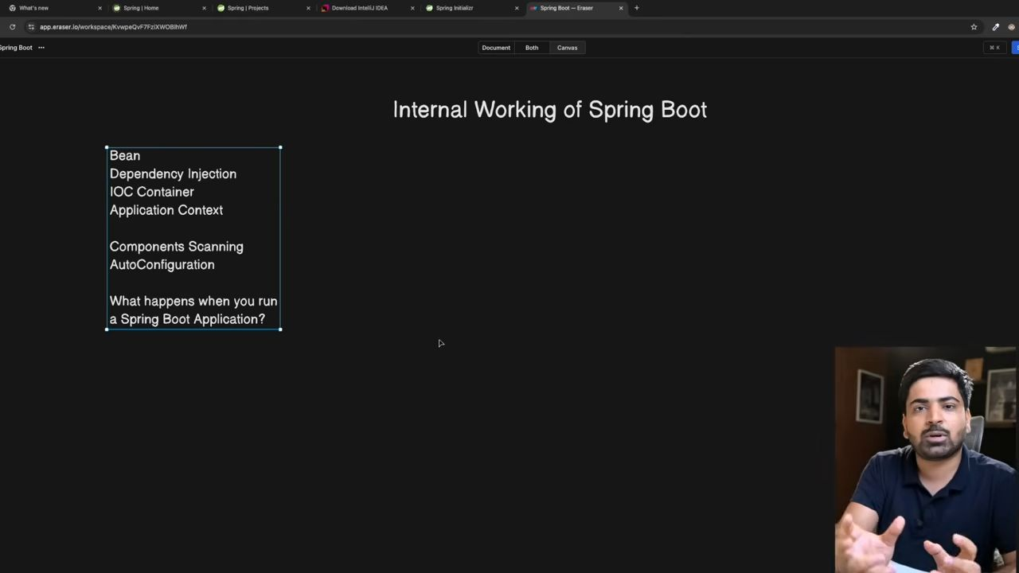
01:30
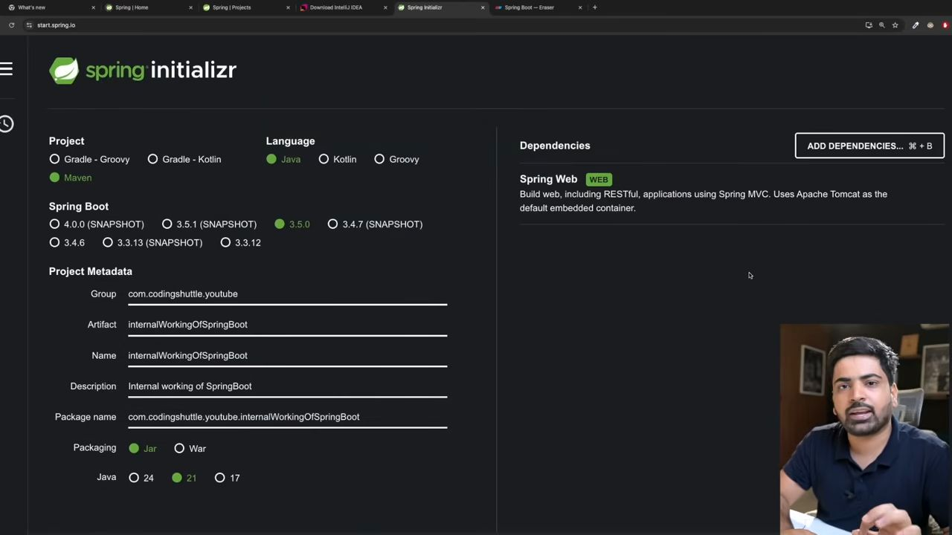
04:48
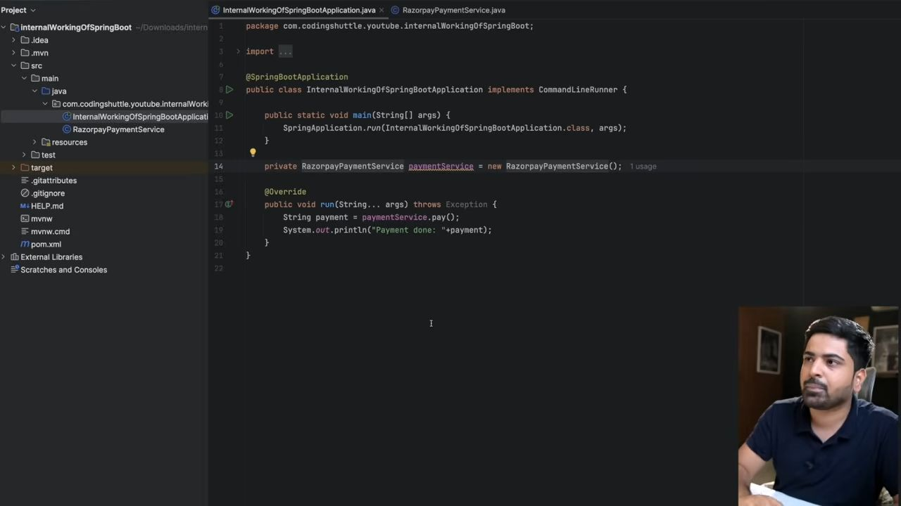
In this example there is tight coupling happening. Currently we are using only Razorpay; maybe another time we will use PhonePe, UPI, credit card, etc. So in order to do that, I need to make changes in this class, which I don't want to do. I want Ki Ye to run the time when he decides which payment service I should usewithout affecting the class. And to do this we use the concept of bean and dependency injection.
Beans are the Java objects that are managed by the Spring container.
So, to create a class, a bean, add the @Component annotation to that class.
05:58
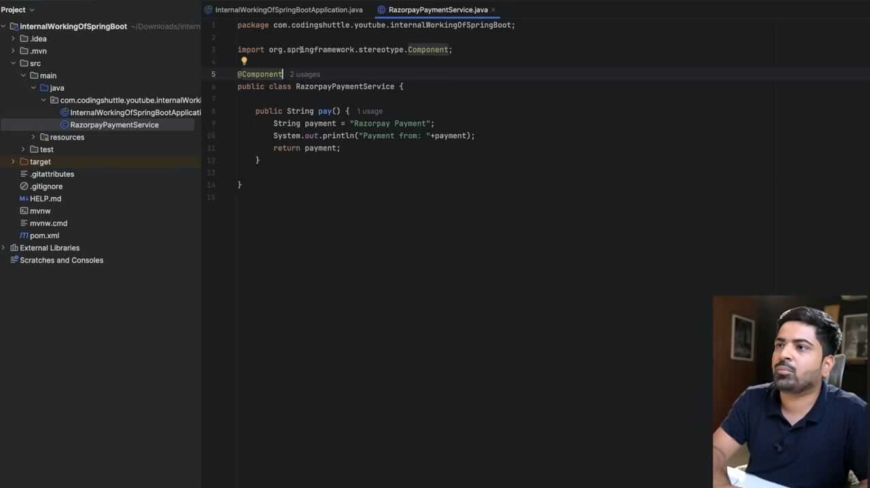
Jaha Jaha spring pure code ko scan krta hai and jidhr pe component annotation milta hai, wo uska bean bana k apne pass rakh leta hai.
Now ab hume object banne ki need nhi h.
06:43
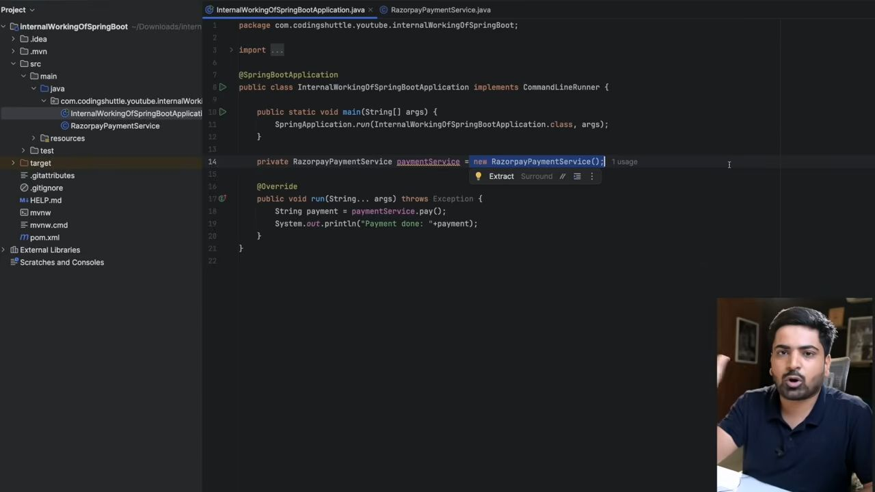
06:47
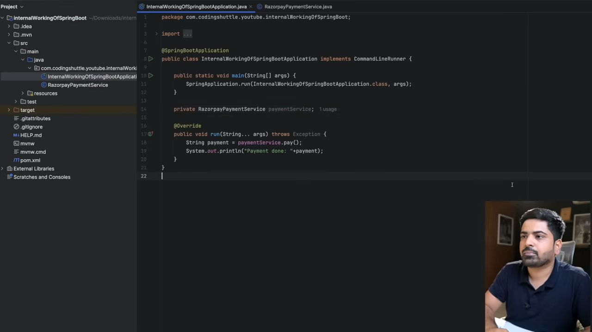
07:16
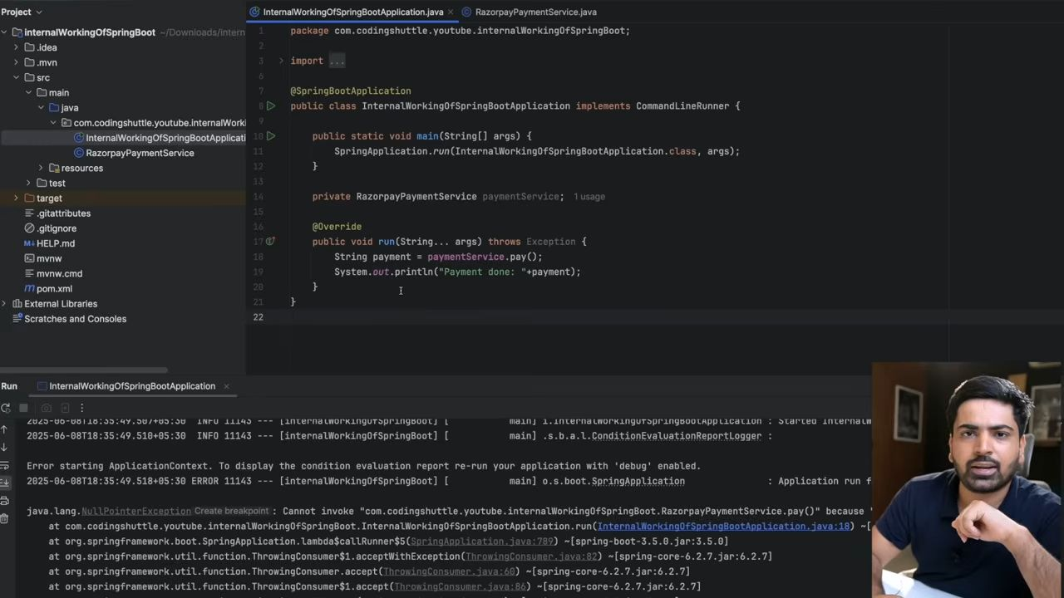
It gives a null pointer exception because we have created the bean of the Razorpay class but haven't used it yet.
Constructor dependency Injection
We have 2 ways to use this bean in our class.
The first way is to make our class dependent on the bean class, which means without the bean class, our class does not exist.
Like a car dependent on an engine.
Do so to create a constructor and pass the bean reference as an argument to it.
08:11
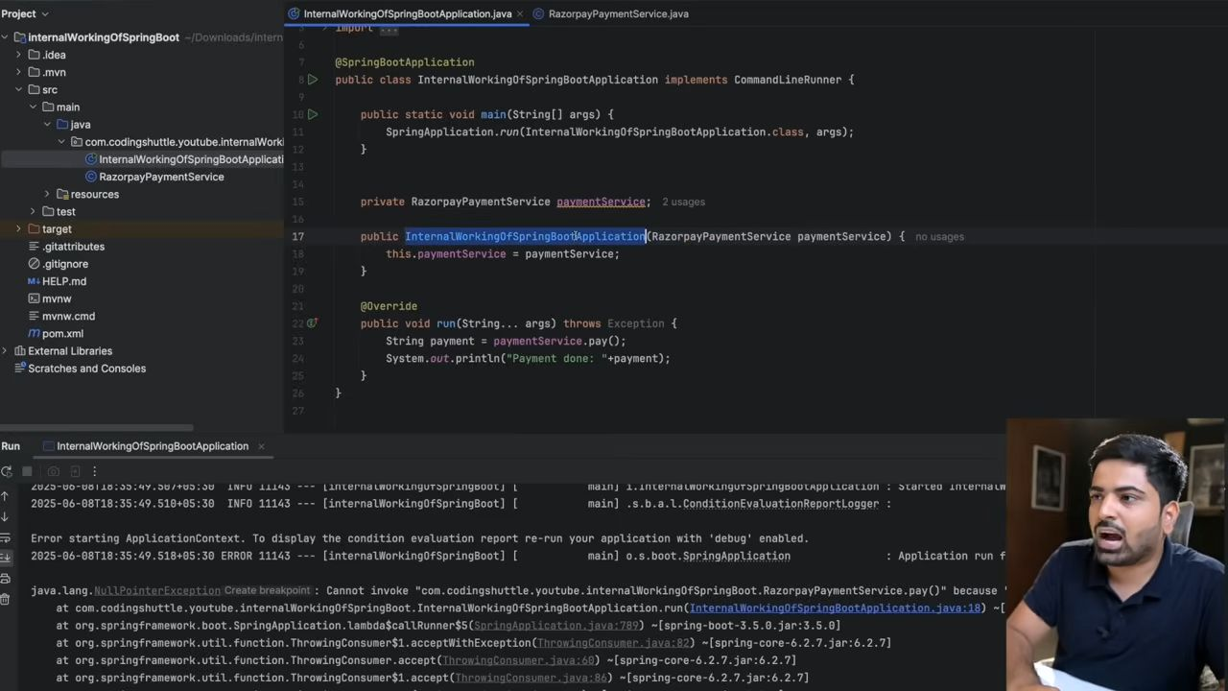
Constructor ki help se mai bean ko inject kara dunga; that is called dependency injection.
09:25
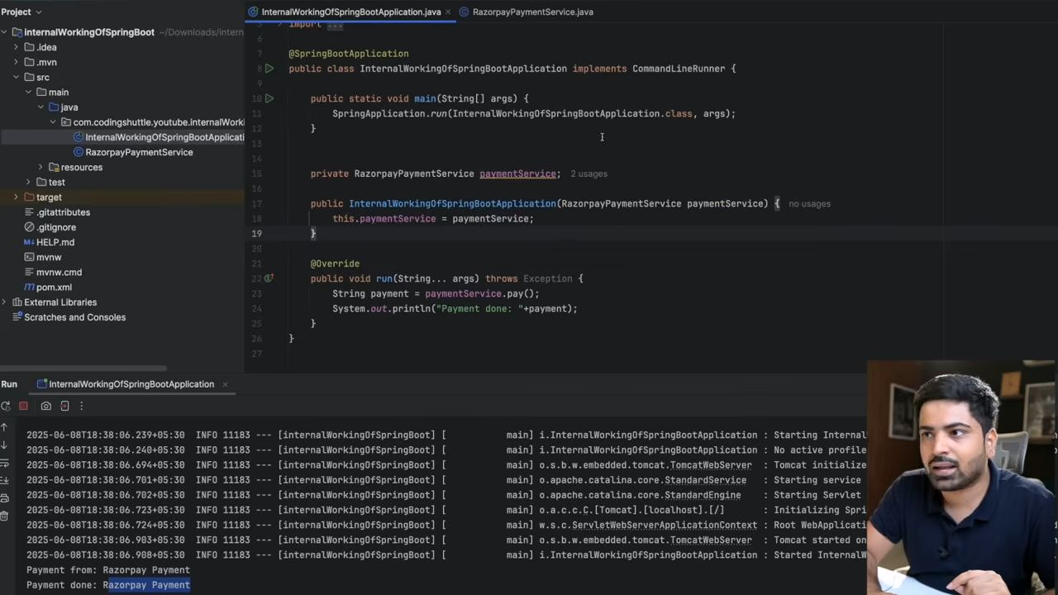
Here we are not using the new keyword, but the Razorpay object has been created. And ye bana dependency injection ki help se.
Field Dependency Injection
10:29
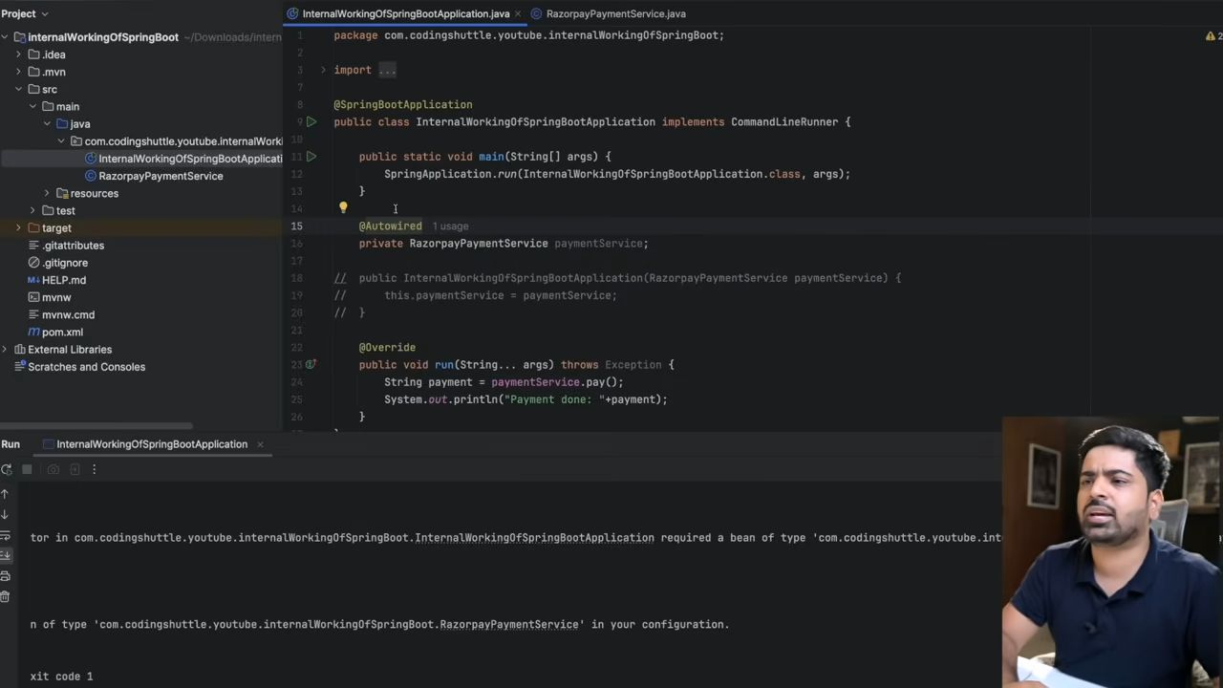
Field dependency injection can be done using autowired annotation. But it is not usually recommended.
@Autowired also tells Spring that we need dependency injection here also.
Autowired k case mai aap varaible ko final nhi bana skte but constructor k case mai bana skte ho.
16:14
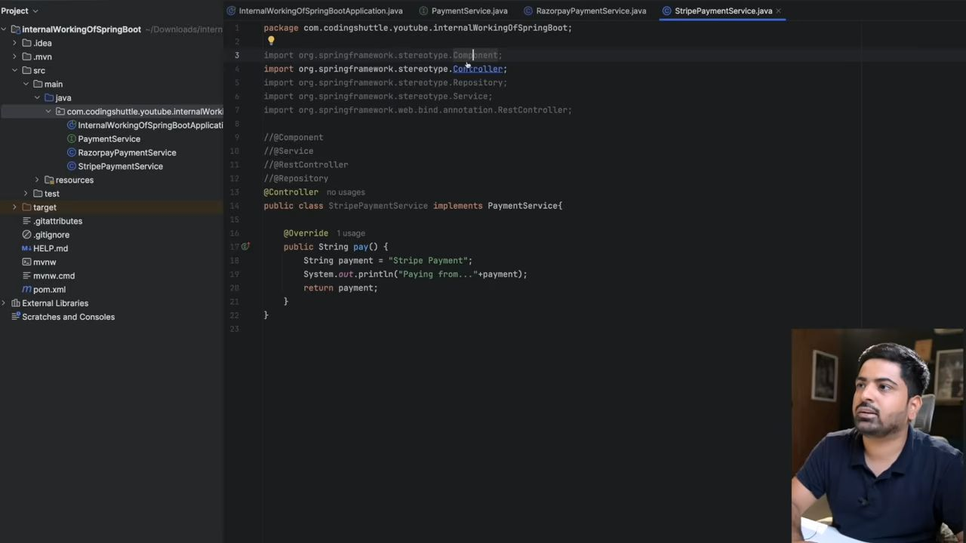You can apply any annotation; all will mark your class as a bean.
18:05
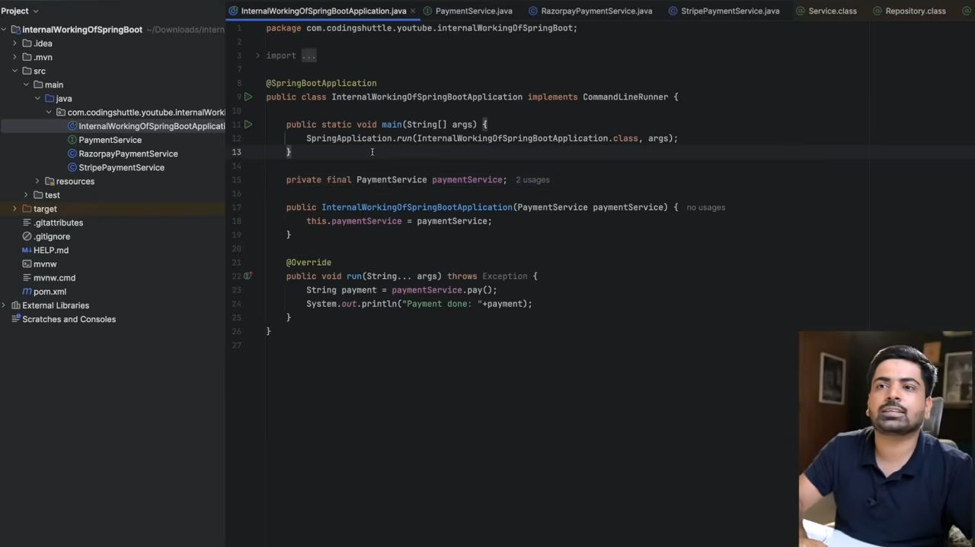
18:38
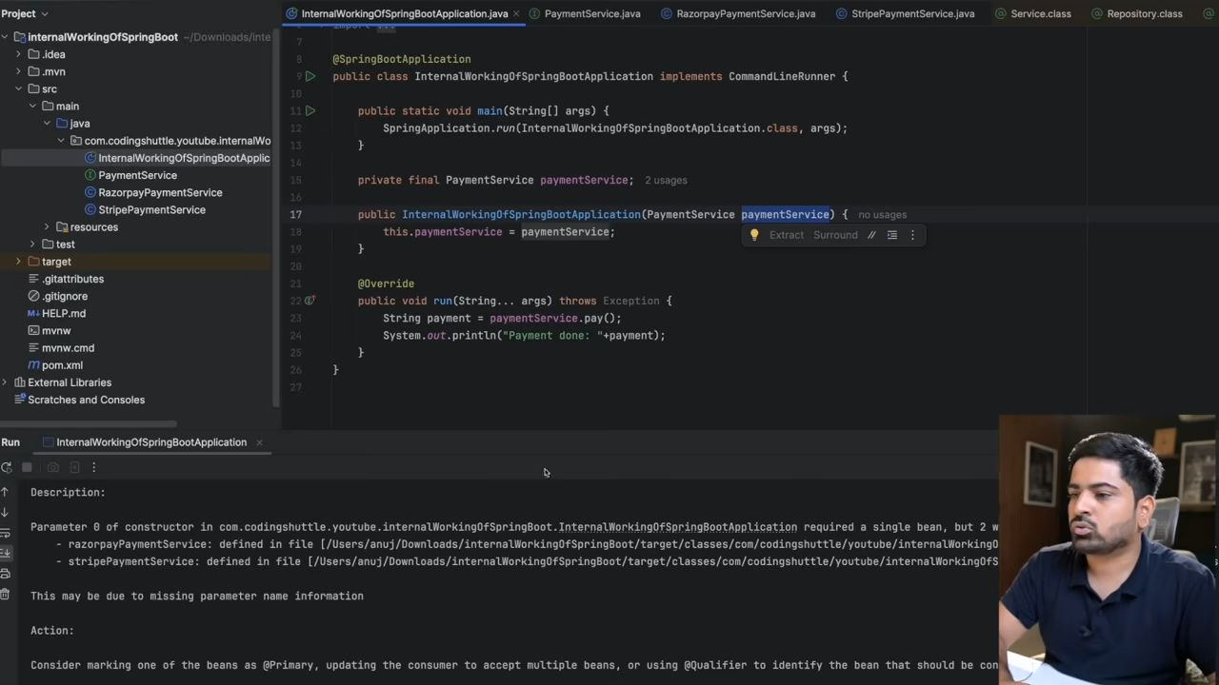
Ab hum PaymentService ka use krenge na ki Razorpay ka, but ab isme ek problem aa gyi hai, wo ye hai ki...PaymentService ki 2 implementation hai, ek Razorpay wali and ye Stripe wali. 2 bean dikhre hai usko, but wo konsa use kre?
Kisi ek mai se component hata do toh wo bean nhi krega, and ab hamra code loosely coupled hai.
We want ki code ko uncomment na kre kyuki baar baar recompile krna padta hai and wo ek best practic bhi ni h. So hum kya kr skte hai ki application.properties file mai apni configuration bata skte hai and udhr se pick kr lega payment interface ki kis bean ko use krna hai.
21:21
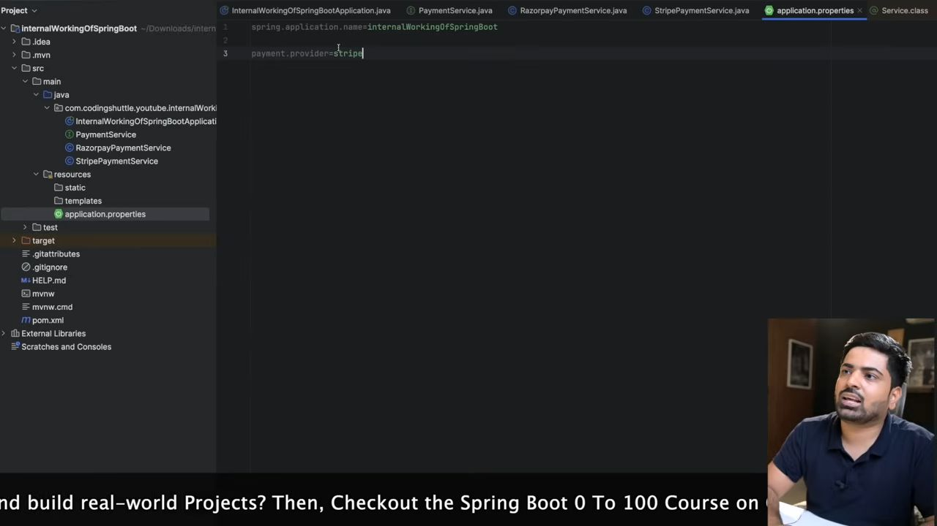Ab mai apne beans ko conditionally bataunga ki konsa bean banana chahiye and konsa nhi. Uske liye hum ek annotation use karenge.
21:53
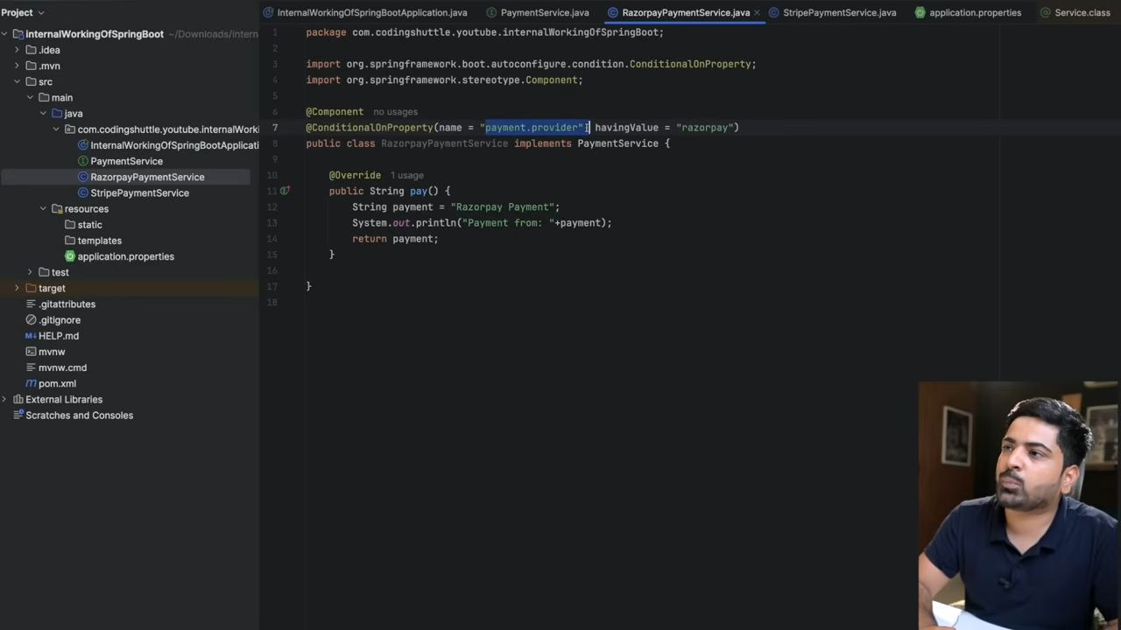
22:14
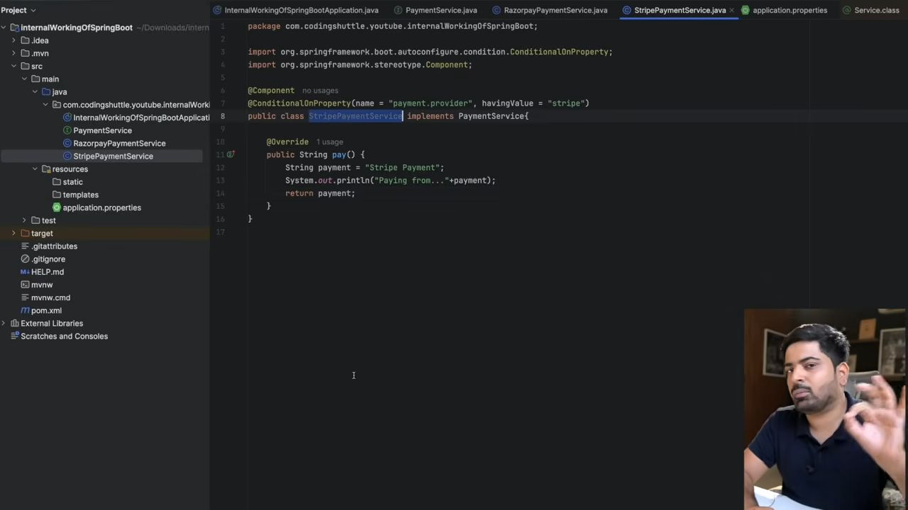
22:35
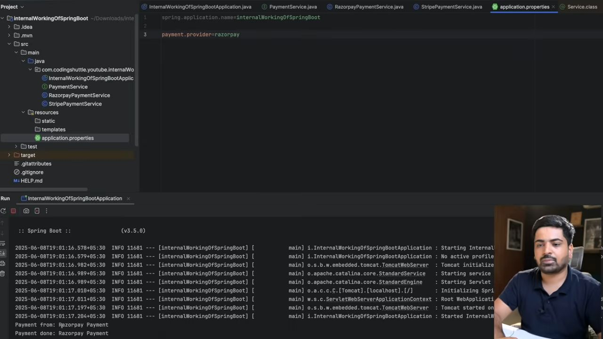
Yaha pe Conditional k base pe bean banre hai and iske bhaut tareke hai like conditional on class, etc.
24:47
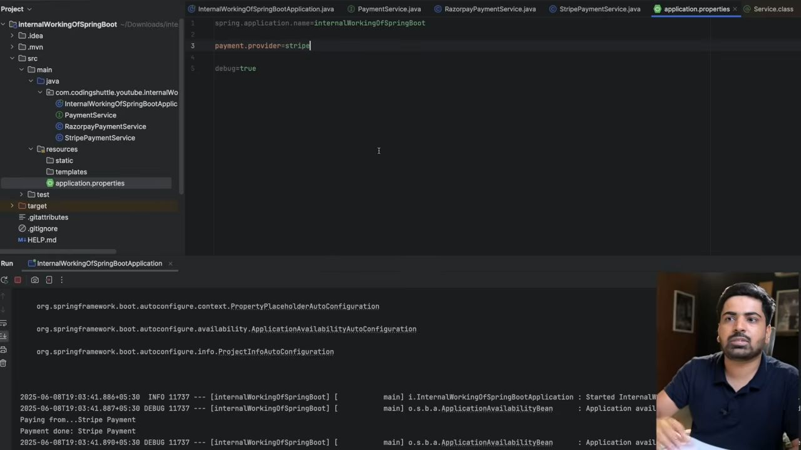
Property Hume bhaut jaha se de sakte hai, not only from the application.properties file only.
25:00
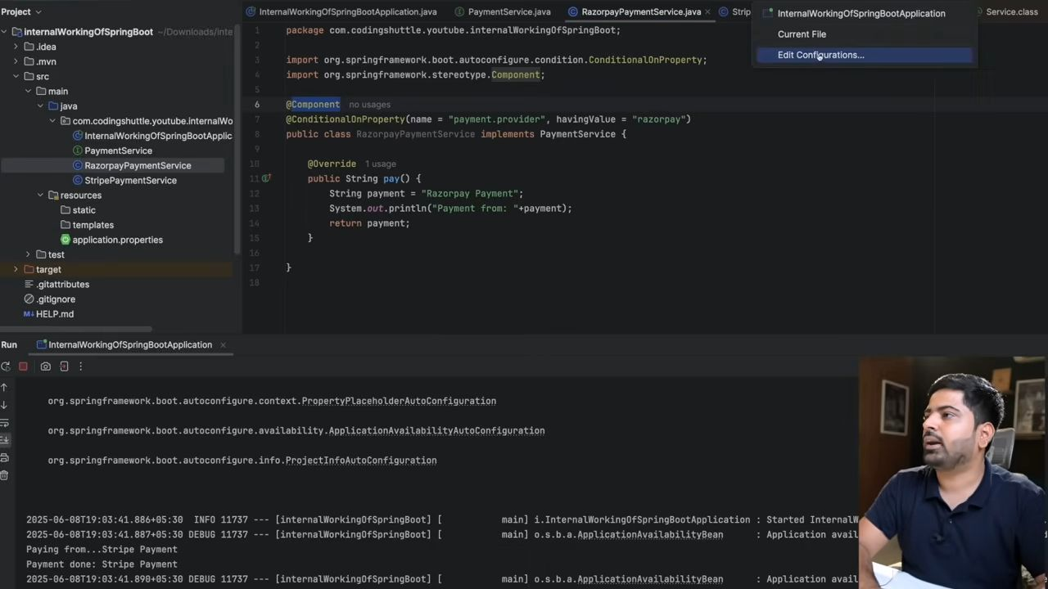
25:26
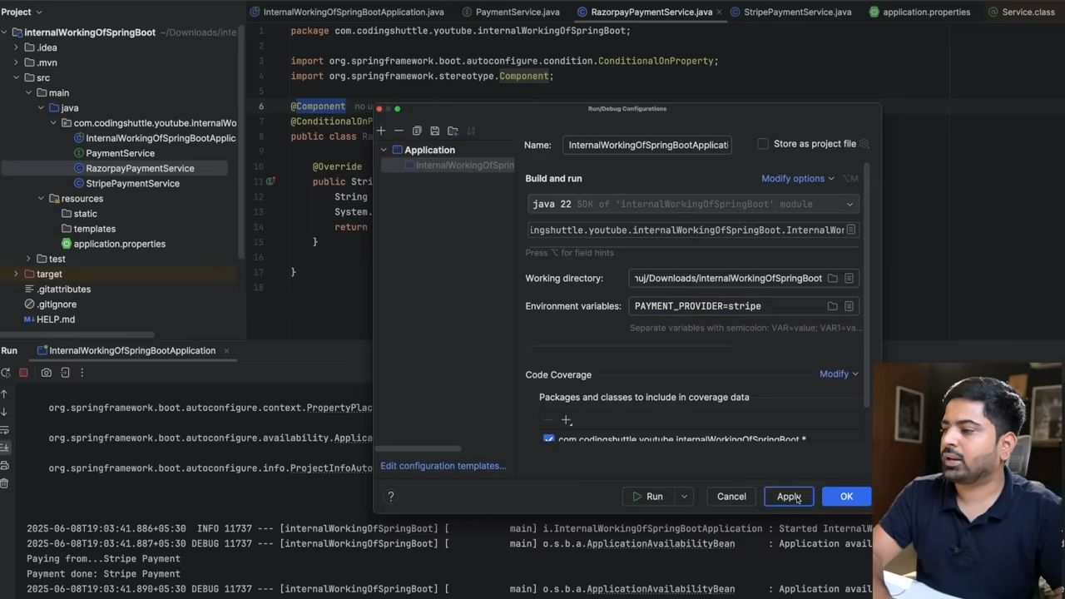
Now it will take this env wali property na ki application. properties wali.
27:09
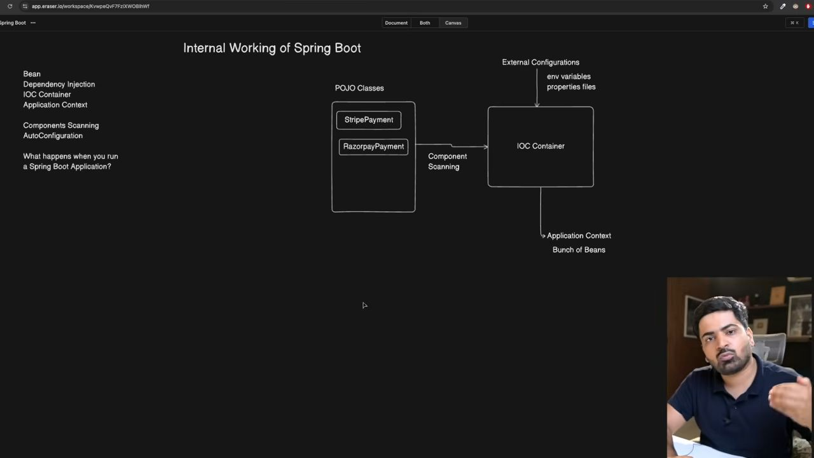
Jab hum apni application ko run krte hai, toh IOC container applicationContext ko banata hai.
Application Context banta hai uske ander beans aate hai, and wahi fir beans supply krta hai har jagha.
Component scanning ke time mai sirf wahi files scan hoti hai jo apke package ke ander hai.
@SpringBootApplication ye entire project mai sirf ek he hota hai. And issi mai main method bhi hota hai, which is the entry point of our program.
@SpringBootApplication = @SpringBootConfiguration + @EnableAutoConfiguration + @EnableAutoConfiguration
Spring ko springBoot banate hai auto configuration feature.
What Happens When you run your springBoot Project.
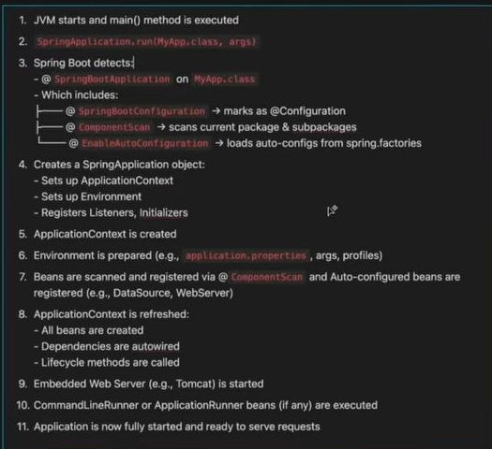

Some Extra Jo ki Padh Leni Chaheye.
Got it 👍 Let’s break down how @Primary and @Qualifier work in Spring (mainly in Spring Boot).

1. The Problem They Solve
When you use Dependency Injection in Spring, sometimes you have multiple beans of the same type in the context.
Spring won’t know which bean to inject, so it throws an error (NoUniqueBeanDefinitionException).
Example:
@Component
class Dog implements Animal {
public String sound() {
return "Bark";
}
}
@Component
class Cat implements Animal {
public String sound() {
return "Meow";
}
}
@Component
class Zoo {
private final Animal animal;
@Autowired public Zoo(Animal animal) { this.animal = animal; }
}
👉 Here, Spring gets confused because we have two beans of type Animal (Dog and Cat).

2. Solution 1: @Primary
@Primary tells Spring:
“If multiple beans of the same type exist, choose this one by default.”
@Component
@Primary
class Dog implements Animal {
public String sound() {
return "Bark";
}
}
@Component
class Cat implements Animal {
public String sound() {
return "Meow";
}
}
Now when Spring injects Animal, it automatically picks Dog, unless we explicitly specify otherwise.

3. Solution 2: @Qualifier
@Qualifier tells Spring:
“Use this specific bean by name.”
@Component
class Dog implements Animal {
public String sound() {
return "Bark";
}
}
@Component
class Cat implements Animal {
public String sound() {
return "Meow";
}
}
@Component
class Zoo {
private final Animal animal;
@Autowired public Zoo(@Qualifier("cat") Animal animal) { this.animal = animal; }
}
Here, even though both beans exist, Spring will inject the Cat bean because of the @Qualifier("cat").

4. @Primary vs @Qualifier
- @Primary: Sets a default bean to inject when there’s ambiguity.
- @Qualifier: Lets you explicitly choose which bean to inject.
👉 If both are used:
- @Qualifier overrides @Primary.
Example:
@Component
@Primary
class Dog implements Animal { ... }
@Component
class Cat implements Animal { ... }
@Component
class Zoo {
@Autowired
public Zoo(@Qualifier("cat") Animal animal) {
this.animal = animal; // Cat will be injected, even though Dog is @Primary
}
}
✅ In short:
- Use @Primary when you want a default choice.
- Use @Qualifier when you want fine-grained control.

What is @SpringBootApplication?
It is a shortcut annotation in Spring Boot.
Instead of writing three separate annotations, you can just write one.

It combines:
- @SpringBootConfiguration – marks the class as a configuration class (like @Configuration in Spring).
- @EnableAutoConfiguration – tells Spring Boot to automatically configure beans based on dependencies in the classpath.
- Example: If you add spring-boot-starter-web, Spring Boot auto-configures Tomcat, DispatcherServlet, etc.
- @ComponentScan – tells Spring to scan the current package and its sub-packages for components (@Component, @Service, @Repository, @Controller, etc.).
Great 👍 Let’s walk through what happens step by step when you run a Spring Boot app with @SpringBootApplication and the main method.

Example Main Class
@SpringBootApplication
public class MyApplication {
public static void main(String[] args) {
SpringApplication.run(MyApplication.class, args);
}
}

Step-by-Step Flow of Execution

1. JVM Starts the Application
- The main method is called.
- SpringApplication.run(MyApplication.class, args) is executed.

2. SpringApplication Object is Created
- Spring Boot creates a SpringApplication instance.
- It checks what type of application it is:
- Servlet-based (Web app using Tomcat/Jetty/Undertow)
- Reactive (WebFlux)
- Non-web (console app)

3. Environment Setup
- Spring Boot prepares the Environment (properties, profiles, system variables).
- It loads application.properties or application.yml if they exist.
- Active profiles are applied (e.g., dev, test, prod).

4. Banner Display
- By default, the Spring Boot banner (ASCII art) is printed in the console.
- You can customize or disable it.

5. ApplicationContext Creation
- Spring Boot creates an ApplicationContext (the Spring container).
- The type depends on the app:
- AnnotationConfigServletWebServerApplicationContext → Web App
- AnnotationConfigReactiveWebServerApplicationContext → Reactive
- AnnotationConfigApplicationContext → Non-Web

6. Component Scanning
- Because of @SpringBootApplication → @ComponentScan:
- Spring scans the current package and sub-packages for beans.
- It finds @Component, @Service, @Repository, @Controller, etc.

7. Auto-Configuration
- Because of @EnableAutoConfiguration:
- Spring Boot looks at the classpath dependencies and auto-configures beans.
- Example:
- If spring-boot-starter-web is present → Configures Tomcat, DispatcherServlet, JSON converter.
- If spring-boot-starter-data-jpa is present → Configures DataSource, EntityManagerFactory, TransactionManager.

8. Beans are Created and Wired
- Spring Boot creates beans found in scanning and auto-configuration.
- It resolves @Autowired dependencies.

9. Embedded Web Server Starts (If Web App)
- If it’s a web app, the embedded Tomcat/Jetty/Undertow server starts.
- Port (default 8080) is opened.

10. ApplicationRunner / CommandLineRunner
- If you have beans implementing CommandLineRunner or ApplicationRunner, they run just after the context is ready.

11. Application is Ready
- Finally, Spring Boot prints:
Started MyApplication in 2.345 seconds (JVM running for 3.001)
- Now the application is fully running and ready to accept requests (if web).
✅ In Short:
When you run a Spring Boot app:
- main() calls SpringApplication.run().
- Environment & properties are loaded.
- ApplicationContext is created.
- Beans are scanned and auto-configured.
- Dependencies are injected.
- If it’s a web app → Embedded server starts.
- App is ready to use 🚀.

